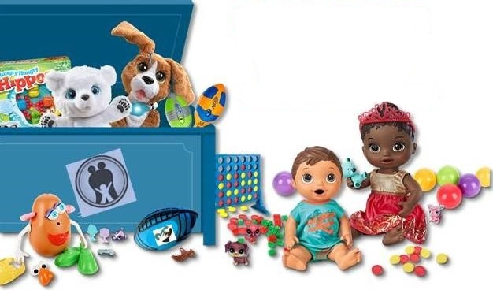

**Beginnings, Inc.**

**2nd Annual Toy Bash**

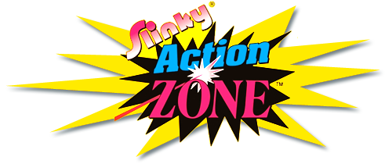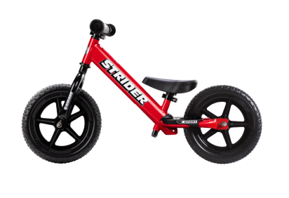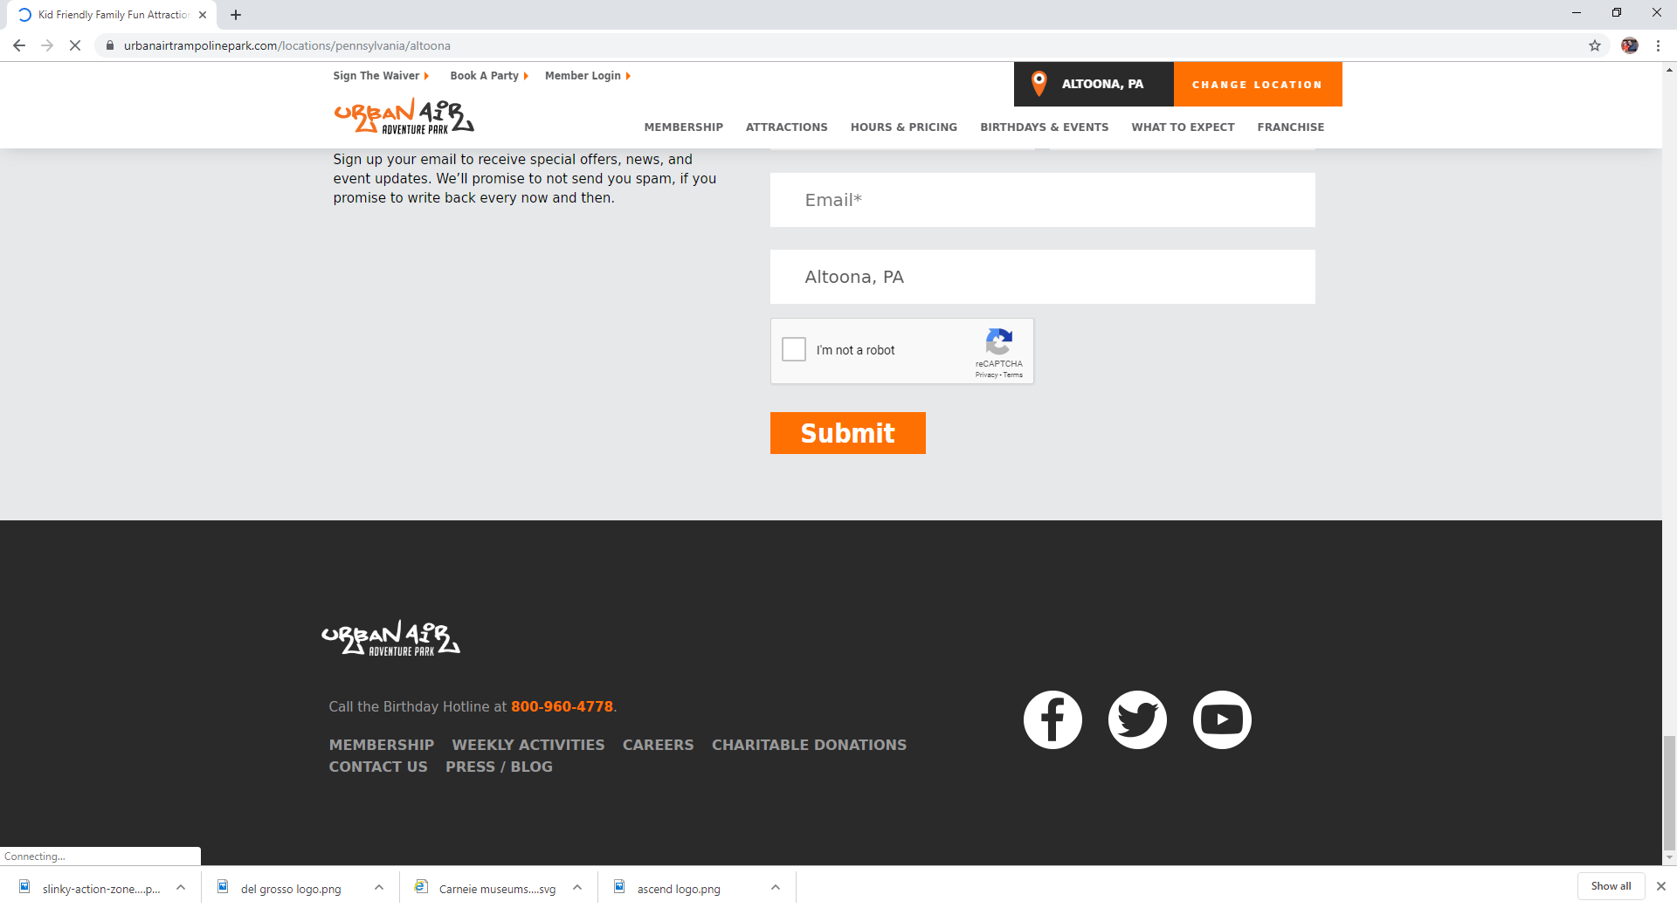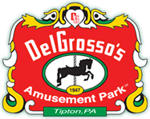

$1,800 in cash and gift cards

Additional chances to win at the event

Sunday, November 10, 2019

1:00- 3:00 (Doors open at 12:30)

Our Son’s Main Event

229 Main St. Downtown Johnstown

Tickets on Sale now!

Find them on Facebook & Eventbrite or

Call 814-539-1919

To get your tickets today!

Need not be present to win